Cone-Based Composite Solids

Definition
# Source: AI Source: Provided by: [Data Path: Persons Table -> ID Column: 1, Name_En Column: Motasem Essam] -> From: [ChatGPT] on [7/25/2026]
Cone-Based Composite Solids are three-dimensional geometric objects formed by joining a cone with one or more other geometric solids that have flat surfaces, curved surfaces, or both.
The resulting solid contains at least one conical component and may have a combination of flat faces, circular bases, conical surfaces, cylindrical surfaces, spherical surfaces, and other curved surfaces.
Examples include:
- A cone attached to a cylinder.
- A cone joined to a hemisphere.
- A cone attached to a rectangular prism.
- Two cones joined base-to-base.
- A cone combined with a sphere and a cylinder.

Simple Definition
# Source: AI Source: Provided by: [Data Path: Persons Table -> ID Column: 1, Name_En Column: Motasem Essam] -> From: [ChatGPT] on [7/25/2026]
A cone-based composite solid is a 3D shape made by combining a cone with one or more other geometric solids.
For example, attaching a cone to the top of a cylinder creates a composite solid with cylindrical and conical curved surfaces and an exposed flat circular base.

Geometric Representation
# Source: AI Source: Provided by: [Data Path: Persons Table -> ID Column: 1, Name_En Column: Motasem Essam] -> From: [ChatGPT] on [7/25/2026]
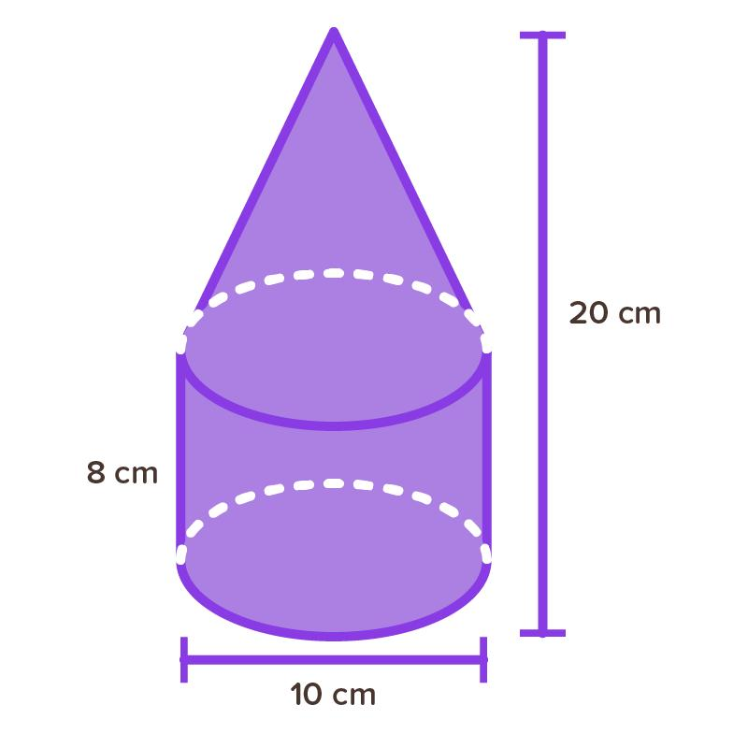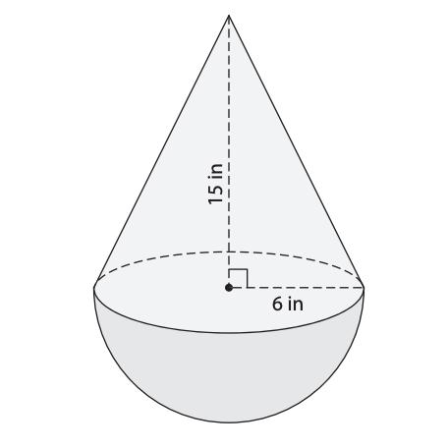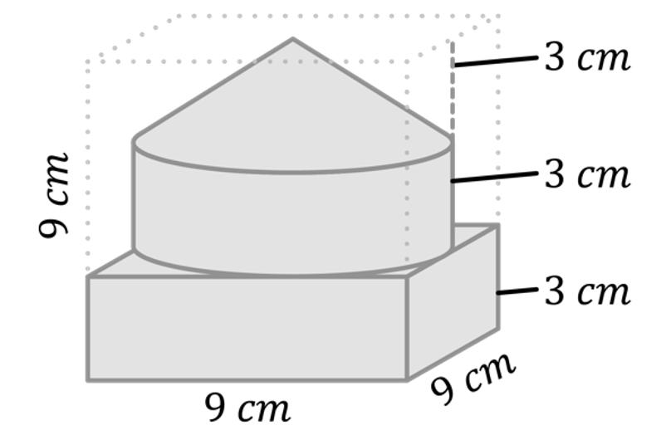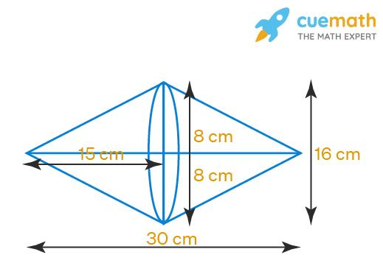
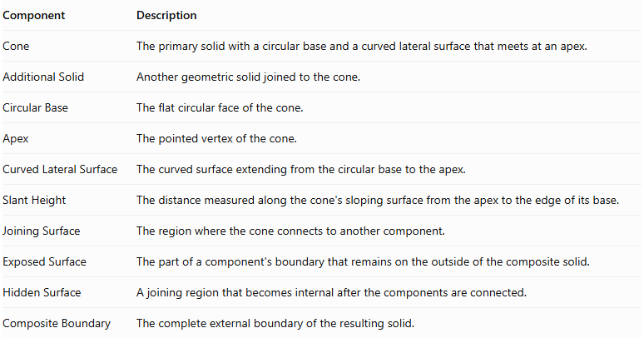
Component | Description
Cone | The primary solid with a circular base and a curved lateral surface that meets at an apex.
Additional Solid | Another geometric solid joined to the cone.
Circular Base | The flat circular face of the cone.
Apex | The pointed vertex of the cone.
Curved Lateral Surface | The curved surface extending from the circular base to the apex.
Slant Height | The distance measured along the cone's sloping surface from the apex to the edge of its base.
Joining Surface | The region where the cone connects to another component.
Exposed Surface | The part of a component's boundary that remains on the outside of the composite solid.
Hidden Surface | A joining region that becomes internal after the components are connected.
Composite Boundary | The complete external boundary of the resulting solid.

Types of Cone-Based Composite Solids

Cone-Cylinder Composite Solids
# Source: AI Source: Provided by: [Data Path: Persons Table -> ID Column: 1, Name_En Column: Motasem Essam] -> From: [ChatGPT] on [7/25/2026]
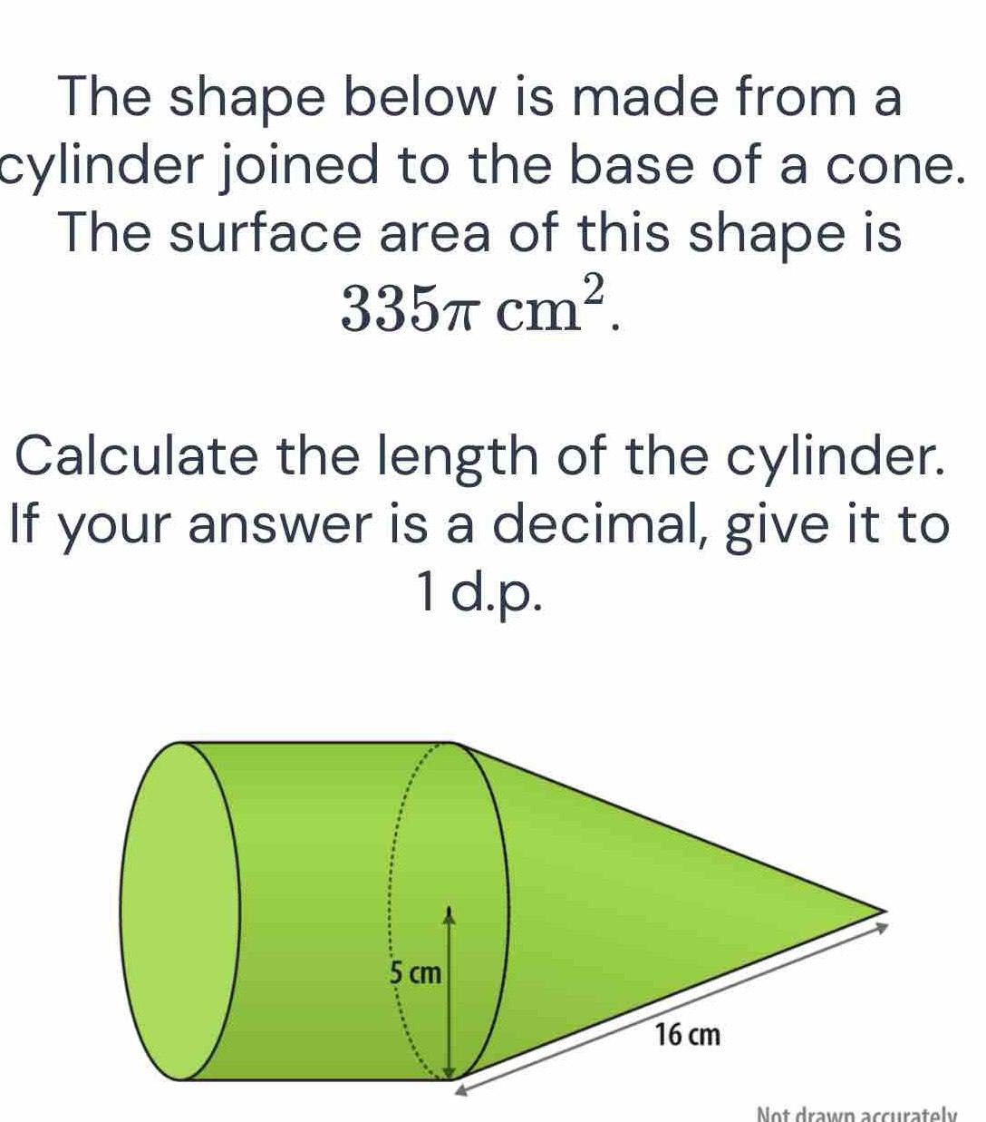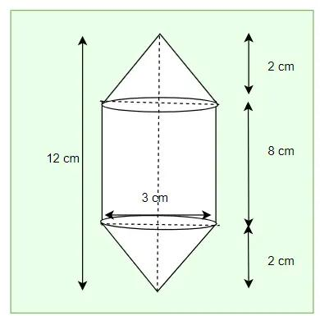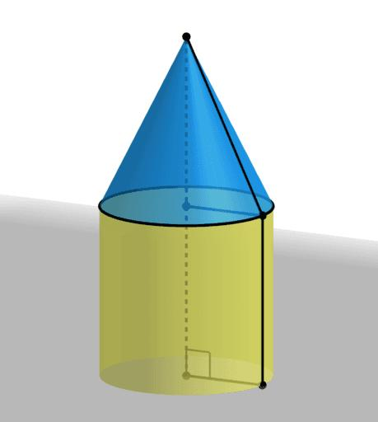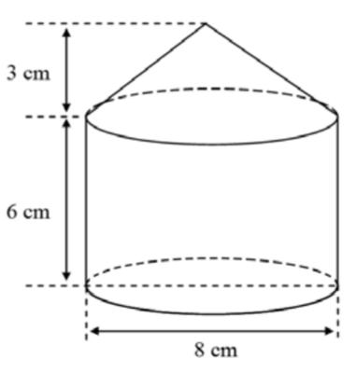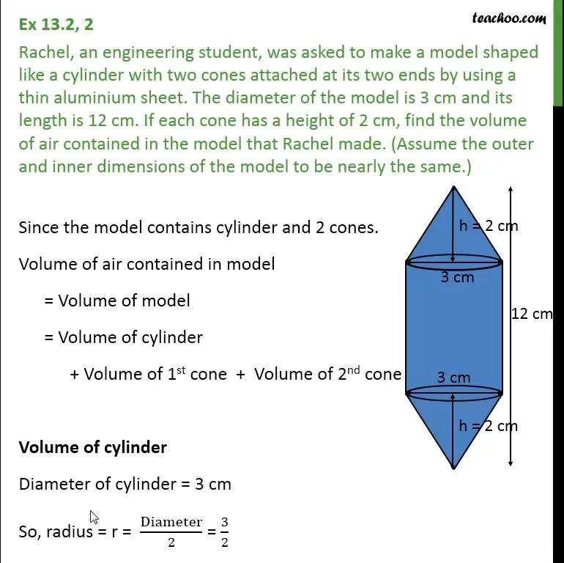
Formed by joining one or more cones with a cylinder.
Examples:
- Cone attached to the top of a cylinder.
- Cone attached underneath a cylinder.
- Cones attached to both ends of a cylinder.
- Multiple cones attached to one cylinder.
- Cone attached to the lateral side of a cylinder.

Cone-Sphere Composite Solids
# Source: AI Source: Provided by: [Data Path: Persons Table -> ID Column: 1, Name_En Column: Motasem Essam] -> From: [ChatGPT] on [7/25/2026]
Formed by combining a cone with one or more spheres.
Examples:
- Cone joined to a sphere.
- Sphere attached near the cone's base.
- Sphere attached near the apex region.
- Cone with multiple spherical components.
- Multiple cones combined with spheres.

Cone-Hemisphere Composite Solids
# Source: AI Source: Provided by: [Data Path: Persons Table -> ID Column: 1, Name_En Column: Motasem Essam] -> From: [ChatGPT] on [7/25/2026]
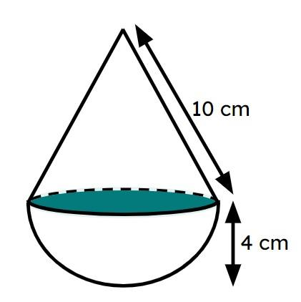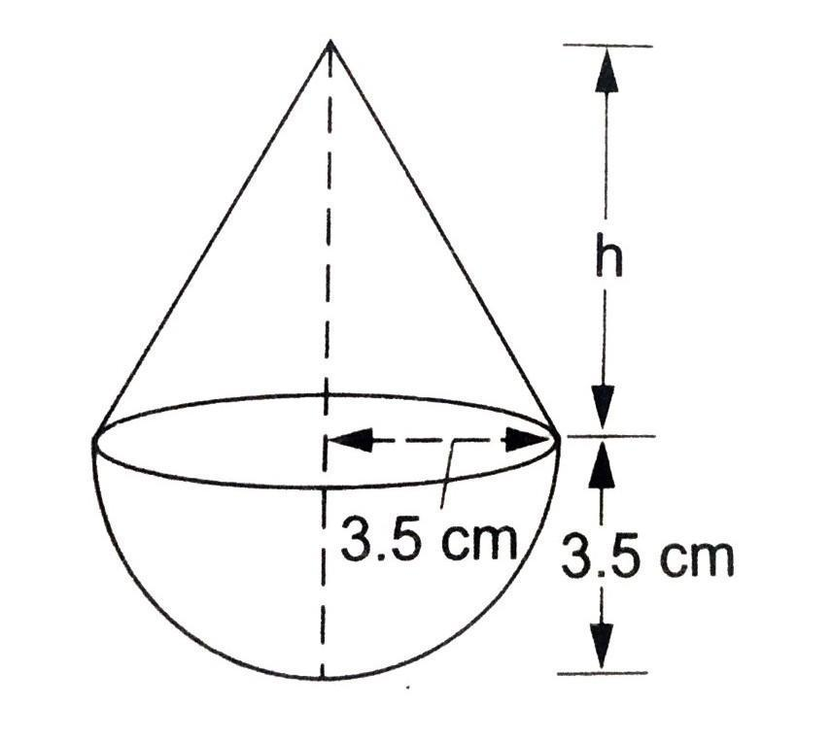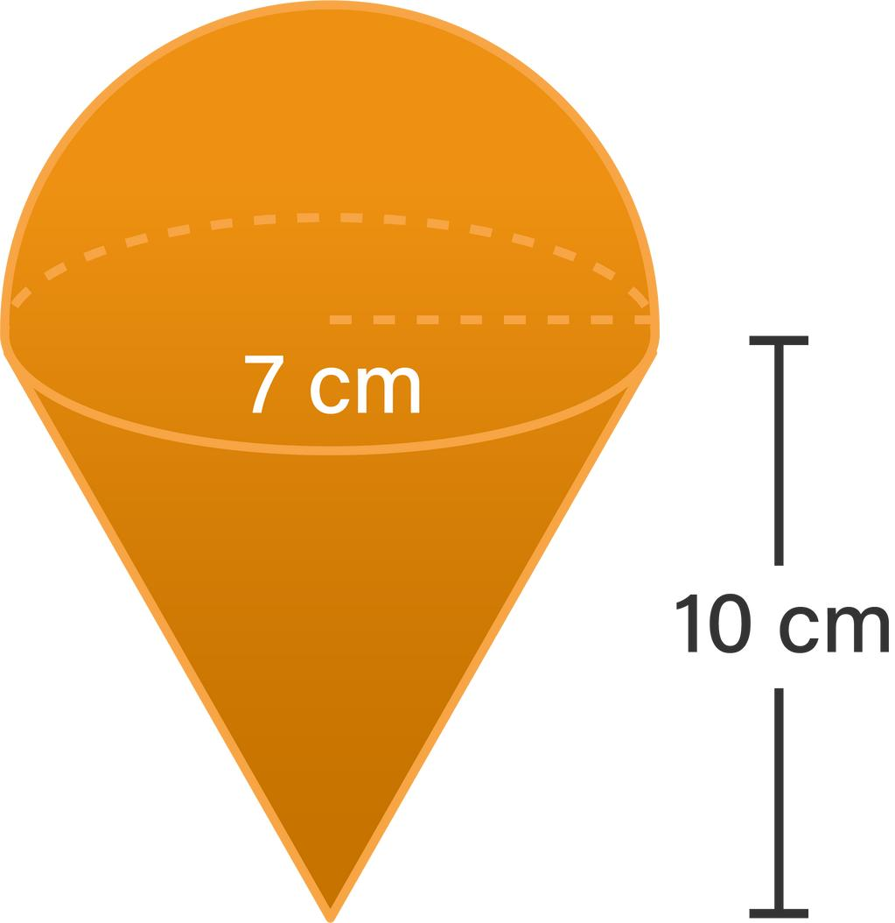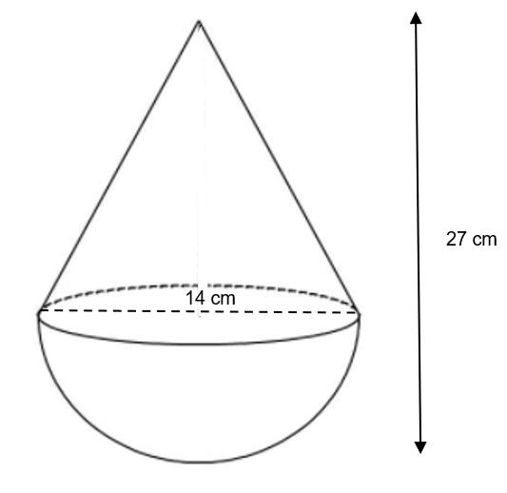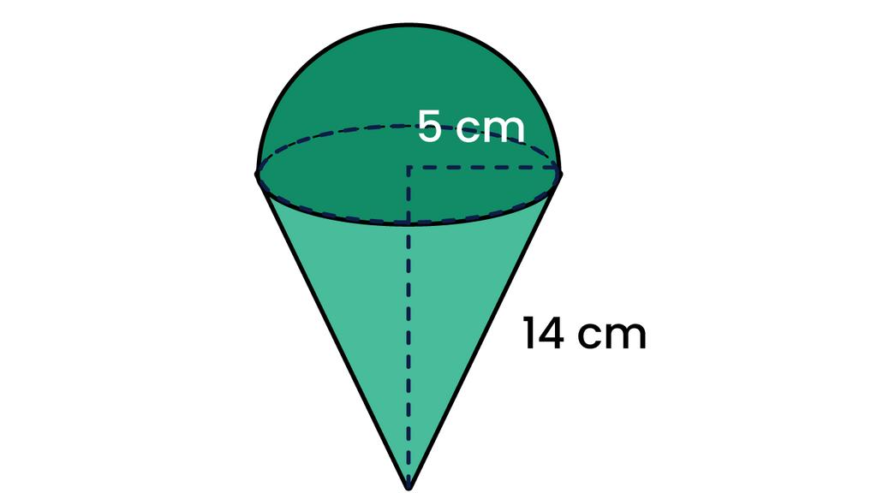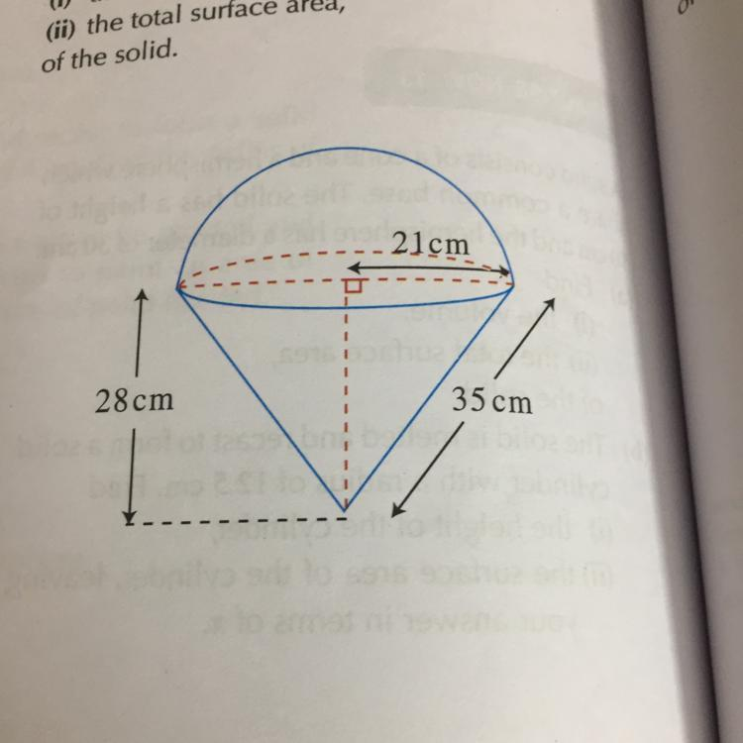
Formed by joining a cone with one or more hemispheres.
Examples:
- Cone attached to a hemisphere through its circular base.
- Hemisphere attached to the cone's base.
- Cone with hemispheres at different positions.
- Multiple cones and hemispheres combined.

Cone-Frustum Composite Solids
# Source: AI Source: Provided by: [Data Path: Persons Table -> ID Column: 1, Name_En Column: Motasem Essam] -> From: [ChatGPT] on [7/25/2026]
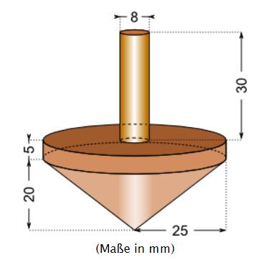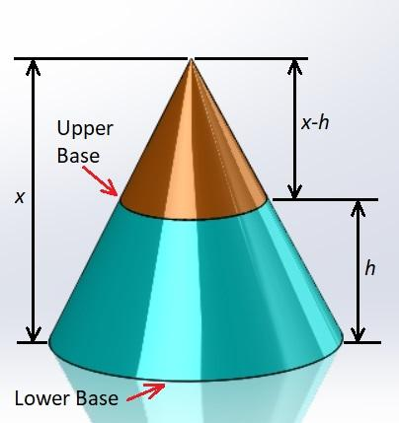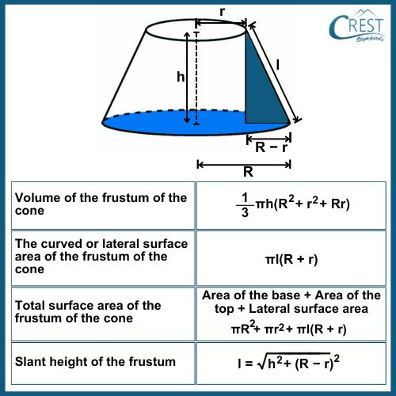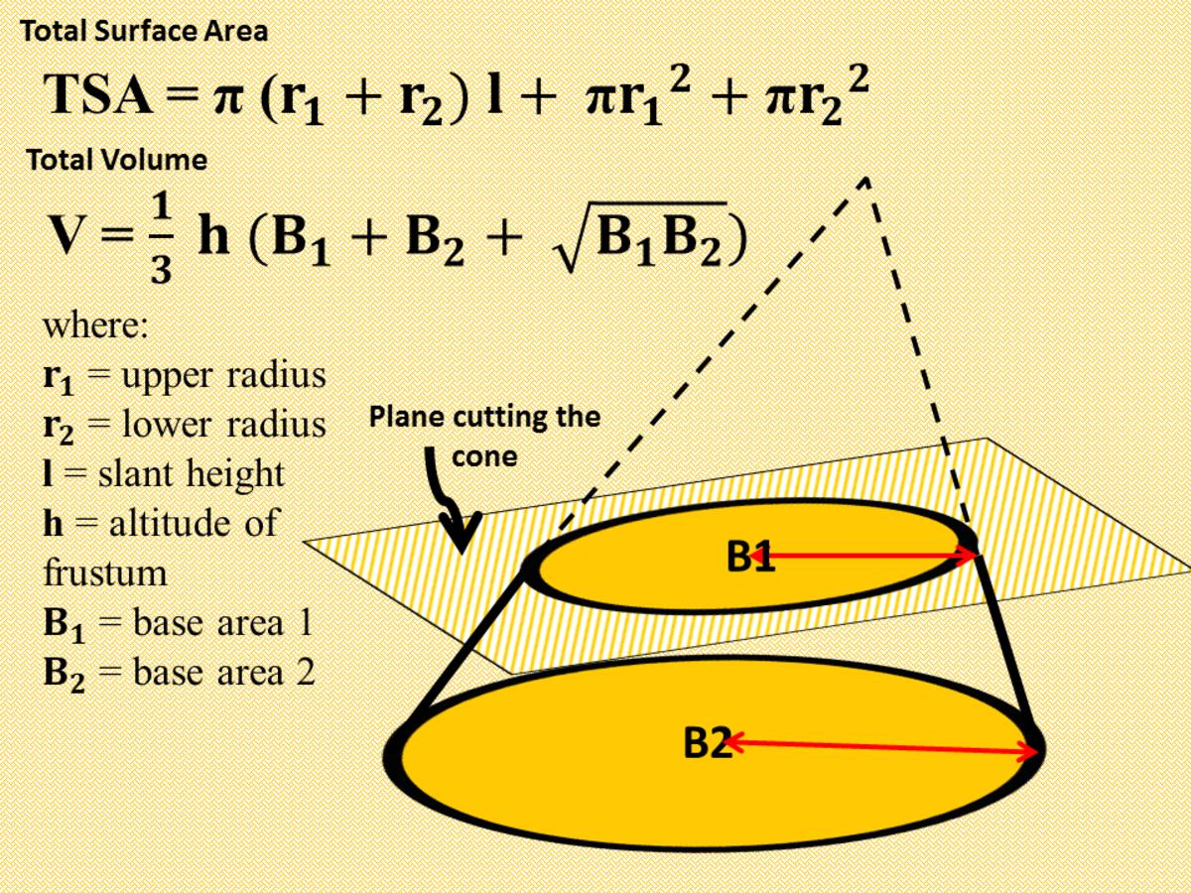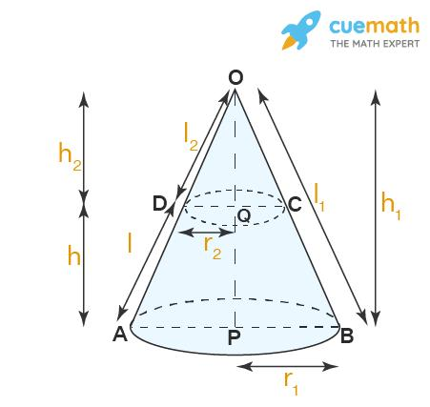
Formed by combining a cone with one or more conical frustums.
Examples:
- Cone attached to the top of a frustum.
- Cone attached underneath a frustum.
- Two cones connected through a frustum.
- Multiple frustums and cones combined.

Cone-Prism Composite Solids
# Source: AI Source: Provided by: [Data Path: Persons Table -> ID Column: 1, Name_En Column: Motasem Essam] -> From: [ChatGPT] on [7/25/2026]
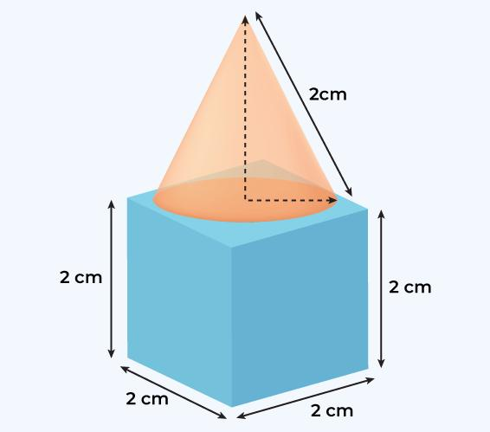
Formed by joining a cone with one or more prisms.
Examples:
- Cone with a rectangular prism.
- Cone with a square prism.
- Cone with a triangular prism.
- Cone with a pentagonal prism.
- Cone with multiple prisms.

Cone-Pyramid Composite Solids
# Source: AI Source: Provided by: [Data Path: Persons Table -> ID Column: 1, Name_En Column: Motasem Essam] -> From: [ChatGPT] on [7/25/2026]
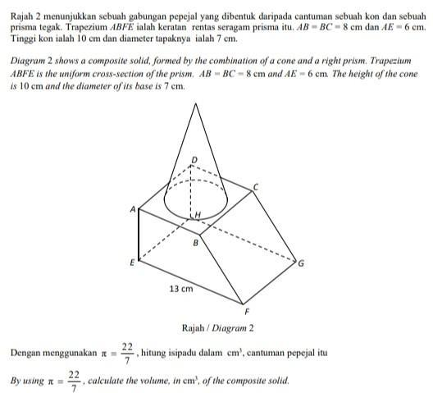
Formed by combining a cone with one or more pyramids.
Examples:
- Cone with a square pyramid.
- Cone with a triangular pyramid.
- Cone with a pyramid attached near its base.
- Cone with multiple pyramids.

Cone with Multiple Curved-Solid Types
# Source: AI Source: Provided by: [Data Path: Persons Table -> ID Column: 1, Name_En Column: Motasem Essam] -> From: [ChatGPT] on [7/25/2026]
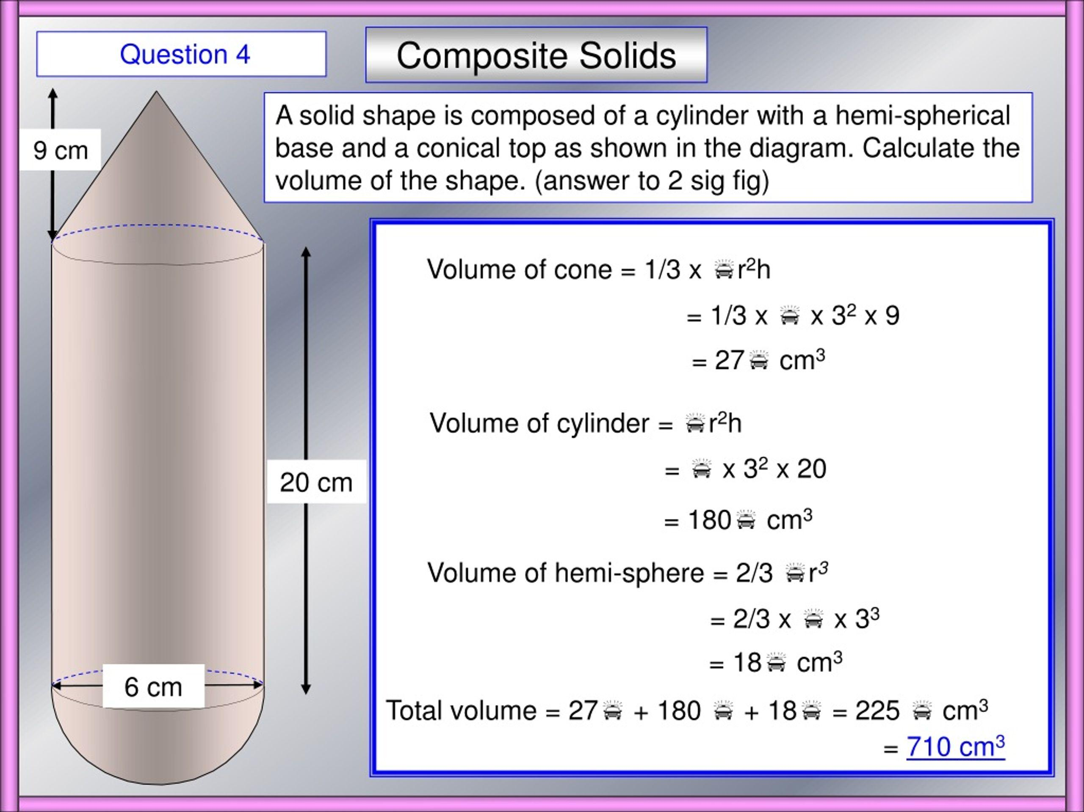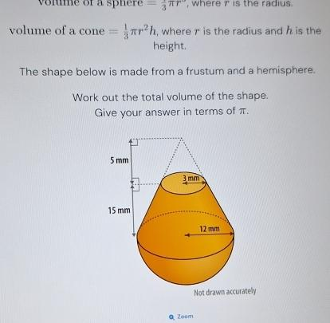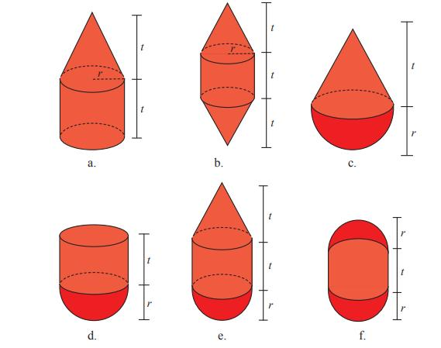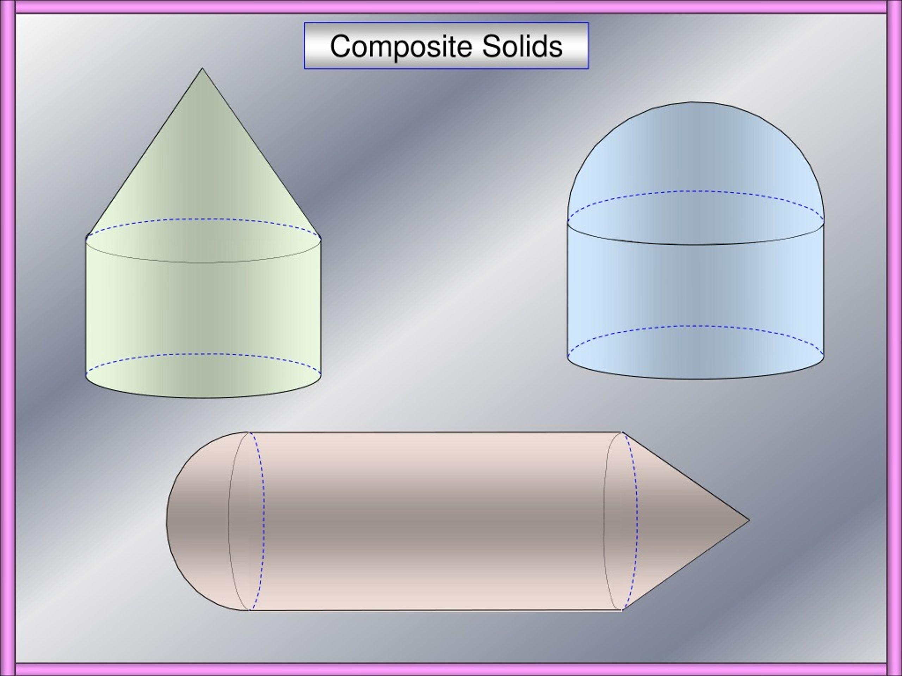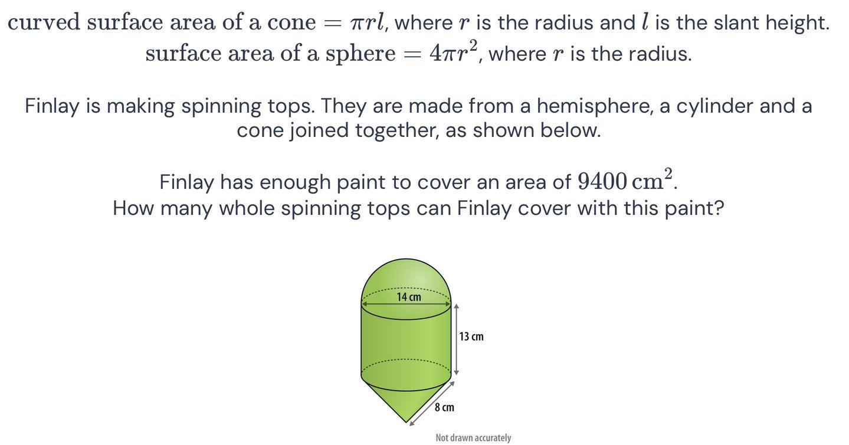
Formed by combining a cone with two or more different types of curved solids.
Examples:
- Cone with a cylinder and hemisphere.
- Cone with a sphere and frustum.
- Cone with multiple hemispheres and cylinders.
- Cone combined with spheres, cylinders, and frustums.

Cone with Multiple Flat-and-Curved Solid Types
# Source: AI Source: Provided by: [Data Path: Persons Table -> ID Column: 1, Name_En Column: Motasem Essam] -> From: [ChatGPT] on [7/25/2026]
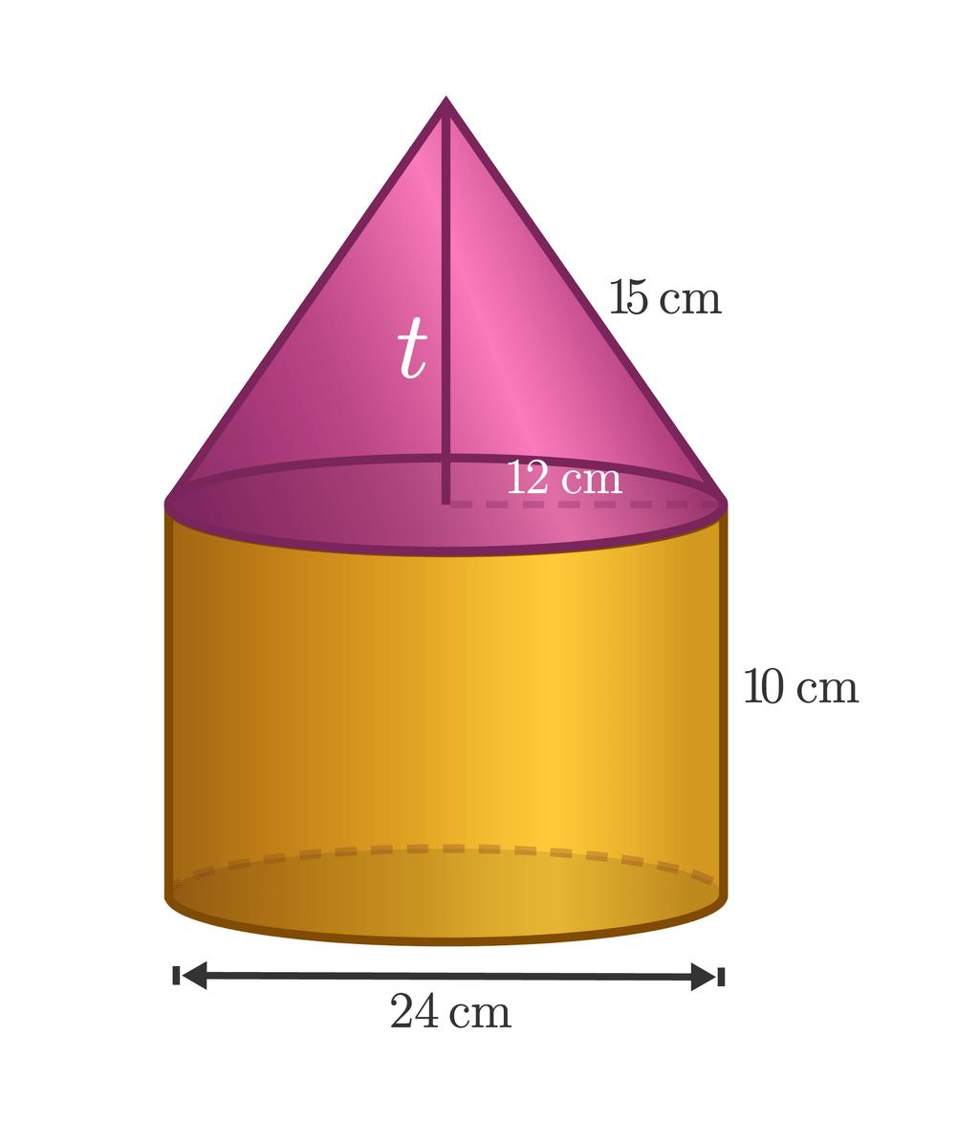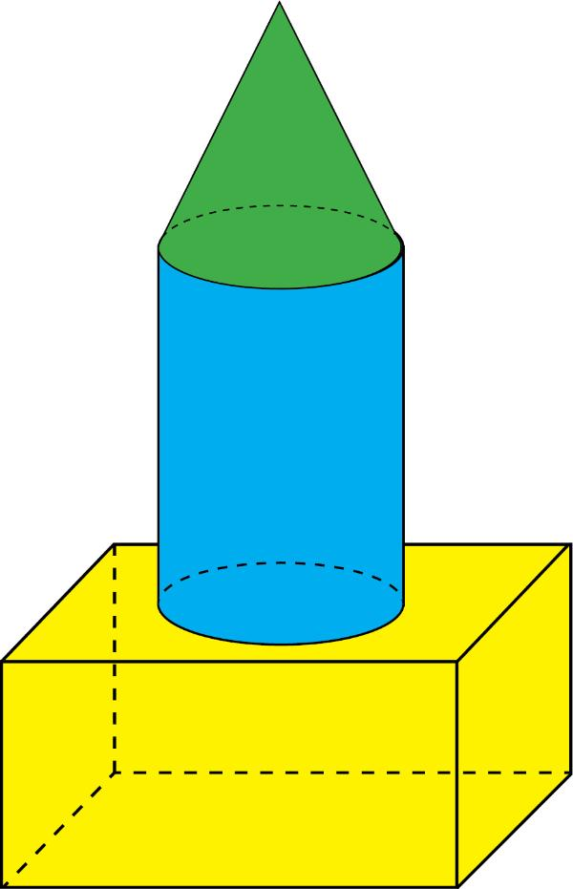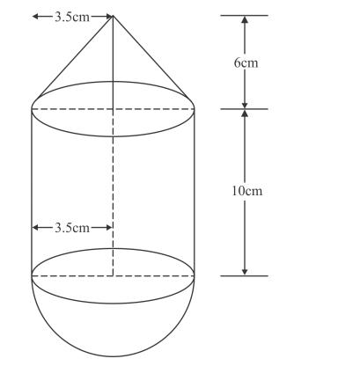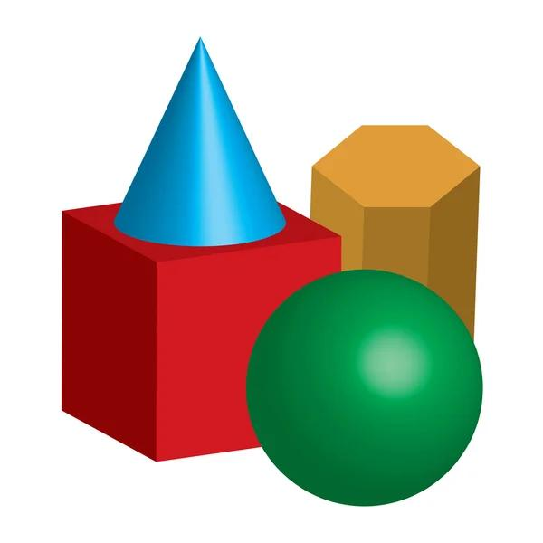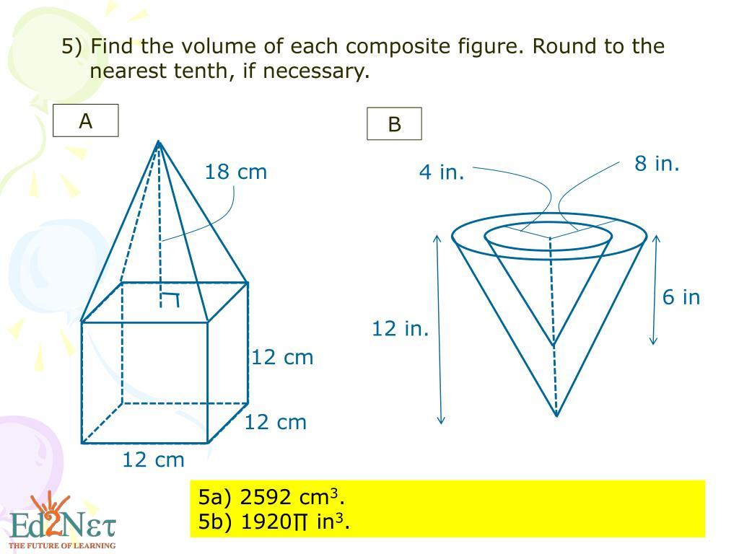
Formed by combining a cone with multiple additional solids that include both flat-faced and curved-surface components.
Examples:
- Cone with a rectangular prism and cylinder.
- Cone with a pyramid and hemisphere.
- Cone with a prism, sphere, and cylinder.
- Cone with multiple prisms, pyramids, and curved solids.

Classification by Cone Type
# Source: AI Source: Provided by: [Data Path: Persons Table -> ID Column: 1, Name_En Column: Motasem Essam] -> From: [ChatGPT] on [7/25/2026]
Cone-based composite solids can be classified according to the type of cone used.
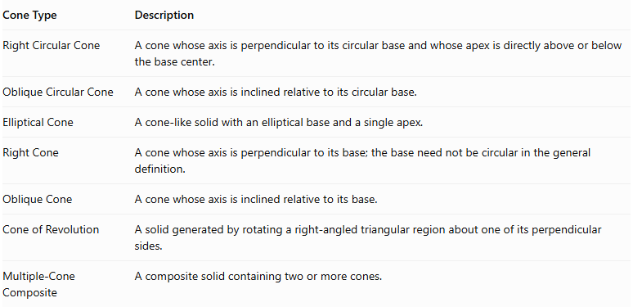
Cone Type | Description
Right Circular Cone | A cone whose axis is perpendicular to its circular base and whose apex is directly above or below the base center.
Oblique Circular Cone | A cone whose axis is inclined relative to its circular base.
Elliptical Cone | A cone-like solid with an elliptical base and a single apex.
Right Cone | A cone whose axis is perpendicular to its base; the base need not be circular in the general definition.
Oblique Cone | A cone whose axis is inclined relative to its base.
Cone of Revolution | A solid generated by rotating a right-angled triangular region about one of its perpendicular sides.
Multiple-Cone Composite | A composite solid containing two or more cones.
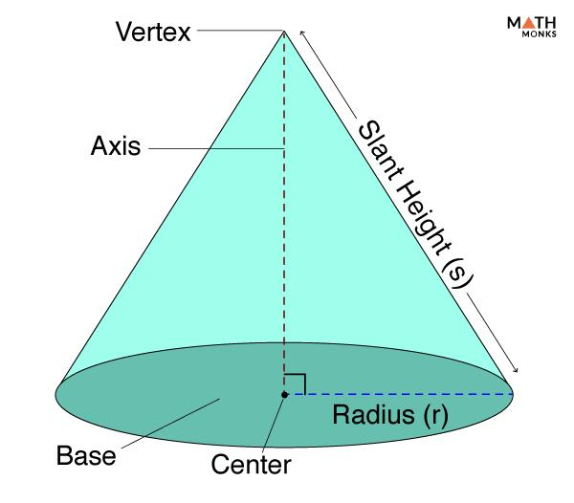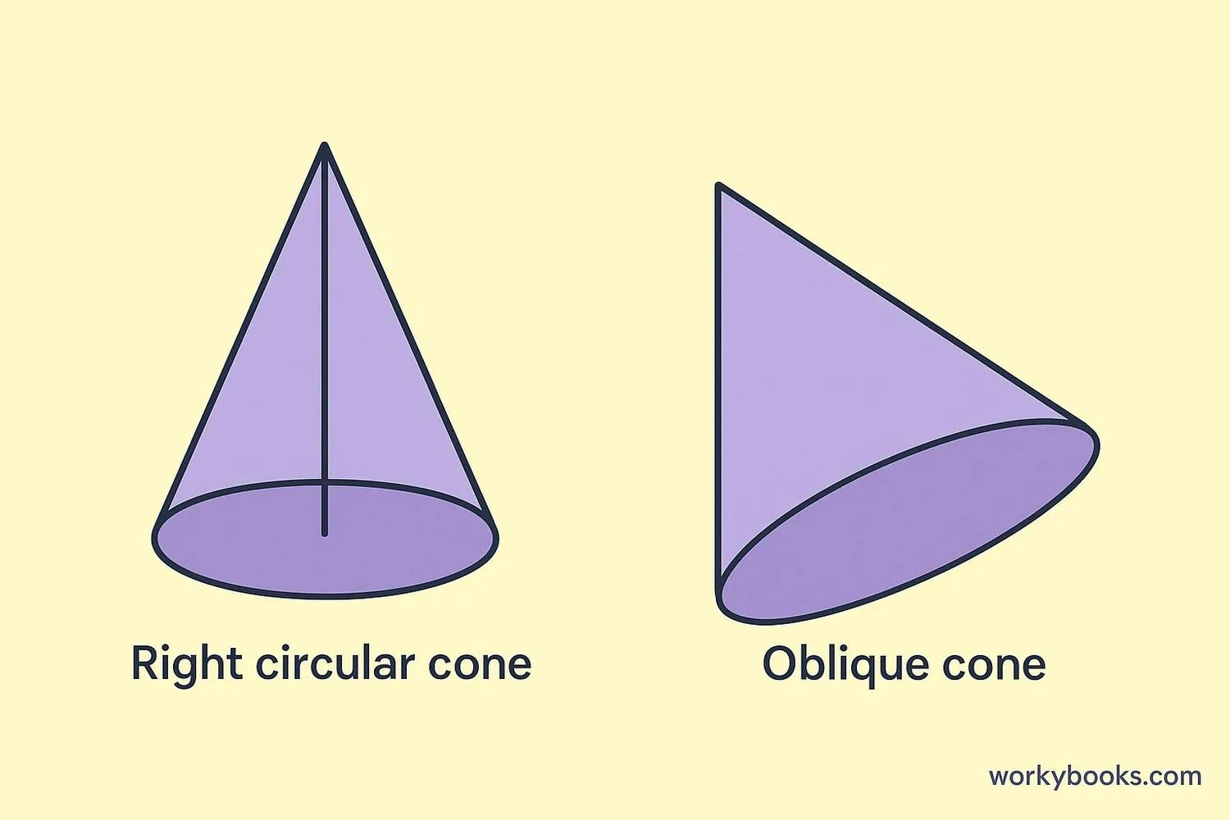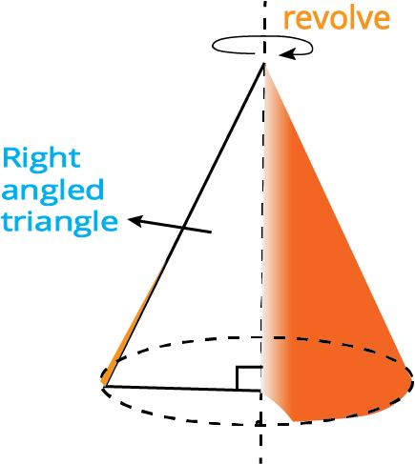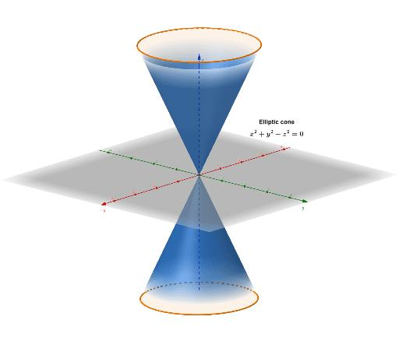

Classification by Arrangement
# Source: AI Source: Provided by: [Data Path: Persons Table -> ID Column: 1, Name_En Column: Motasem Essam] -> From: [ChatGPT] on [7/25/2026]
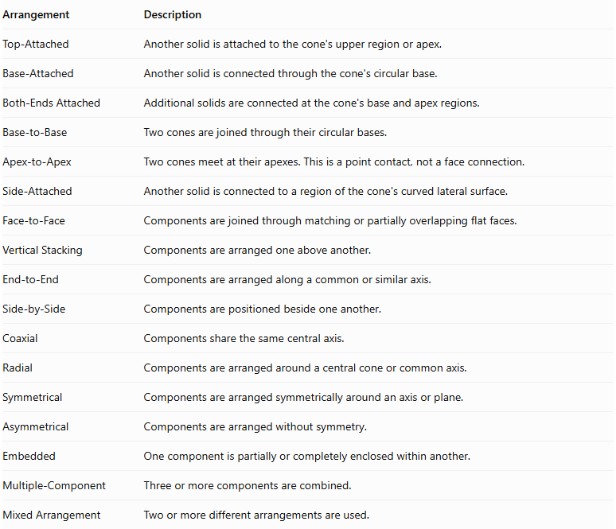
Arrangement | Description
Top-Attached | Another solid is attached to the cone's upper region or apex.
Base-Attached | Another solid is connected through the cone's circular base.
Both-Ends Attached | Additional solids are connected at the cone's base and apex regions.
Base-to-Base | Two cones are joined through their circular bases.
Apex-to-Apex | Two cones meet at their apexes. This is a point contact, not a face connection.
Side-Attached | Another solid is connected to a region of the cone's curved lateral surface.
Face-to-Face | Components are joined through matching or partially overlapping flat faces.
Vertical Stacking | Components are arranged one above another.
End-to-End | Components are arranged along a common or similar axis.
Side-by-Side | Components are positioned beside one another.
Coaxial | Components share the same central axis.
Radial | Components are arranged around a central cone or common axis.
Symmetrical | Components are arranged symmetrically around an axis or plane.
Asymmetrical | Components are arranged without symmetry.
Embedded | One component is partially or completely enclosed within another.
Multiple-Component | Three or more components are combined.
Mixed Arrangement | Two or more different arrangements are used.
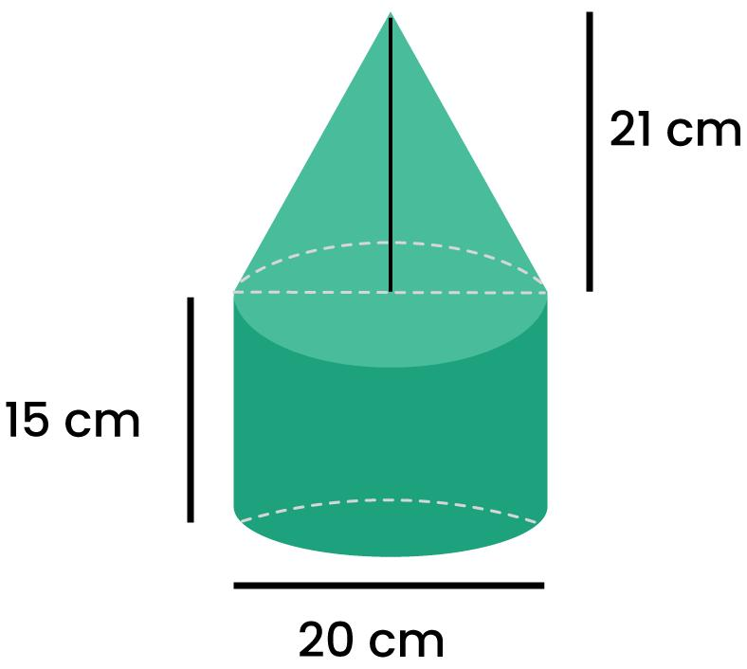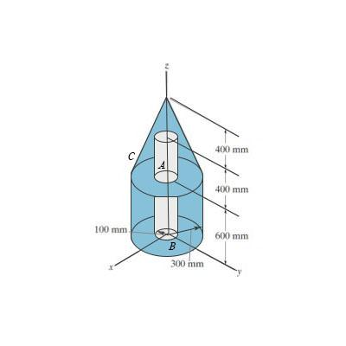

Classification by Surface Combination
# Source: AI Source: Provided by: [Data Path: Persons Table -> ID Column: 1, Name_En Column: Motasem Essam] -> From: [ChatGPT] on [7/25/2026]
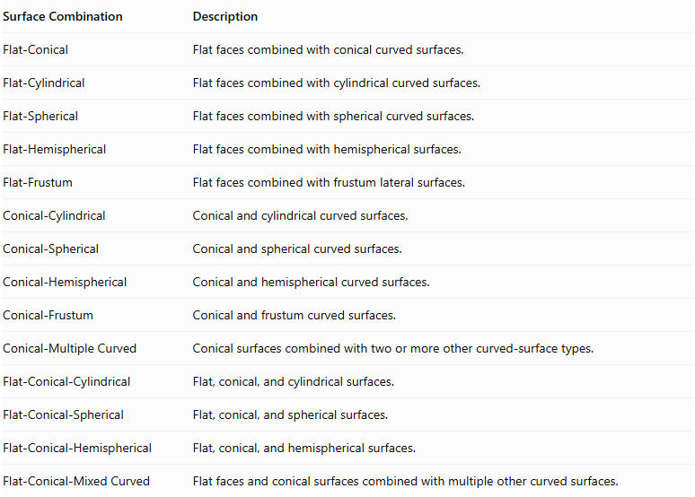
Surface Combination | Description
Flat-Conical | Flat faces combined with conical curved surfaces.
Flat-Cylindrical | Flat faces combined with cylindrical curved surfaces.
Flat-Spherical | Flat faces combined with spherical curved surfaces.
Flat-Hemispherical | Flat faces combined with hemispherical surfaces.
Flat-Frustum | Flat faces combined with frustum lateral surfaces.
Conical-Cylindrical | Conical and cylindrical curved surfaces.
Conical-Spherical | Conical and spherical curved surfaces.
Conical-Hemispherical | Conical and hemispherical curved surfaces.
Conical-Frustum | Conical and frustum curved surfaces.
Conical-Multiple Curved | Conical surfaces combined with two or more other curved-surface types.
Flat-Conical-Cylindrical | Flat, conical, and cylindrical surfaces.
Flat-Conical-Spherical | Flat, conical, and spherical surfaces.
Flat-Conical-Hemispherical | Flat, conical, and hemispherical surfaces.
Flat-Conical-Mixed Curved | Flat faces and conical surfaces combined with multiple other curved surfaces.

Mathematical Properties and Formulas

Volume
# Source: AI Source: Provided by: [Data Path: Persons Table -> ID Column: 1, Name_En Column: Motasem Essam] -> From: [ChatGPT] on [7/25/2026]
The total volume is calculated by adding the volumes of the components when their interiors do not overlap.
$$V_{total}=V_{1}+V_{2}+⋯+V_{n}$$
If the components overlap, their intersection volumes must be subtracted to avoid double-counting.
Important volume formulas:
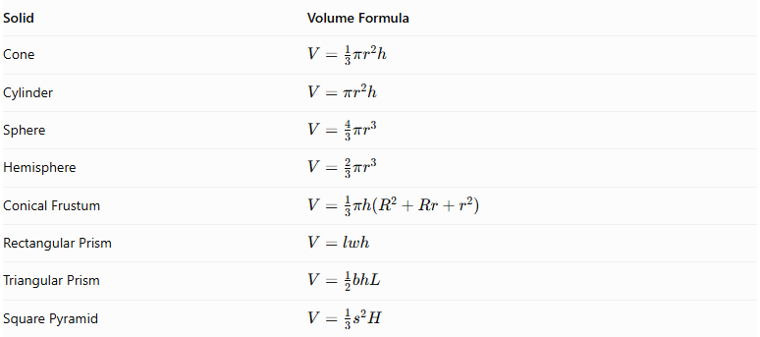
Solid | Volume Formula
Cone | $$V=\frac{1}{3}πr^{2}h$$
Cylinder | $$V=πr^{2}h$$
Sphere | $$V=\frac{4}{3}πr^{3}$$
Hemisphere | $$V=\frac{2}{3}πr^{3}$$
Conical Frustum | $$V=\frac{1}{3}πh(R^{2}+Rr+r^{2})$$
Rectangular Prism | $$V=lwh$$
Triangular Prism | $$V=\frac{1}{2}bhL$$
Square Pyramid | $$V=\frac{1}{3}s^{2}H$$
Where:
- $r$ = radius of a circular base.
- $R$ = larger radius of a frustum.
- $h$ = perpendicular height of the cone or other component.
- $H$ = perpendicular height of a pyramid.
- $l$ = length of a prism.
- $w$ = width.
- $b$ = triangular base width.
- $L$ = length of a triangular prism.
- $s$ = side length of a square base.

Surface Area
# Source: AI Source: Provided by: [Data Path: Persons Table -> ID Column: 1, Name_En Column: Motasem Essam] -> From: [ChatGPT] on [7/25/2026]
The external surface area includes only the surfaces that remain exposed after joining the components.
For two solids joined through a complete matching planar face:
$${SA}_{external}={SA}_{1}+{SA}_{2}-2A_{joining}$$
For partial contact, subtract only the actual hidden contact regions. Curved or intersecting connections require direct calculation of the resulting external boundary.
Important surface-area formulas:
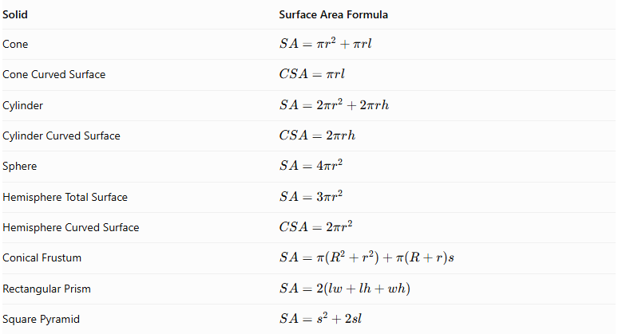
Solid | Surface Area Formula
Cone | $$SA=πr^{2}+πrl$$
Cone Curved Surface | $$CSA=πrl$$
Cylinder | $$SA=2πr^{2}+2πrh$$
Cylinder Curved Surface | $$CSA=2πrh$$
Sphere | $$SA=4πr^{2}$$
Hemisphere Total Surface | $$SA=3πr^{2}$$
Hemisphere Curved Surface | $$CSA=2πr^{2}$$
Conical Frustum | $$SA=π(R^{2}+r^{2})+π(R+r)s$$
Rectangular Prism | $$SA=2(lw+lh+wh)$$
Square Pyramid | $$SA=s^{2}+2sl$$
For a right circular cone:
$$l=\sqrt{r^{2}+h^{2}}$$
For a right circular conical frustum:
$$s=\sqrt{h^{2}+(R-r)^{2}}$$
Here, $l$ and $s$ represent slant heights.

Important Surface-Area Considerations
# Source: AI Source: Provided by: [Data Path: Persons Table -> ID Column: 1, Name_En Column: Motasem Essam] -> From: [ChatGPT] on [7/25/2026]
- The cone's circular base becomes hidden when another solid completely covers it.
- When two cones are joined base-to-base with matching circular bases, both joining disks become internal.
- When a cone is attached to a hemisphere through a matching circular base, the flat joining faces are hidden.
- A cone attached to a prism may have only partial contact because the cone's circular base does not generally match the prism's polygonal face.
- A cone touching another solid only at its apex has point contact, with zero joining area.
- The curved lateral surface of a cone must be counted only where it remains exposed.

Worked Examples

Example 1: Cylinder with a Cone on Top
# Source: AI Source: Provided by: [Data Path: Persons Table -> ID Column: 1, Name_En Column: Motasem Essam] -> From: [ChatGPT] on [7/25/2026]
Given:
A composite solid consists of a cone attached to the top of a cylinder.
Cylinder:
- Radius = 3 cm.
- Height = 8 cm.
Cone:
- Radius = 3 cm.
- Height = 4 cm.
Find the total volume and external surface area.
Step 1: Calculate the cylinder volume.
$$V_{c}=πr^{2}h$$
$$V_{c}=π(3)^{2}(8)=72π$$
Step 2: Calculate the cone volume.
$$V_{cone}=\frac{1}{3}πr^{2}h$$
$$V_{cone}=\frac{1}{3}π(3)^{2}(4)=12π$$
Step 3: Calculate the total volume.
$$V_{total}=72π+12π$$
$$\boxed{V_{total}=84π≈263.89{ cm}^{3}}$$
Step 4: Calculate the exposed cylinder surface area.
The top circular base is hidden by the cone. The exposed cylinder area consists of its curved surface and bottom base.
$${SA}_{c}=2πrh+πr^{2}$$
$${SA}_{c}=2π(3)(8)+π(3)^{2}$$
$${SA}_{c}=57π$$
Step 5: Calculate the cone's curved surface area.
First, calculate its slant height:
$$l=\sqrt{r^{2}+h^{2}}$$
$$l=\sqrt{3^{2}+4^{2}}=5$$
Then:
$${CSA}_{cone}=πrl$$
$${CSA}_{cone}=π(3)(5)=15π$$
Step 6: Calculate the external surface area.
$${SA}_{total}=57π+15π$$
$$\boxed{{SA}_{total}=72π≈226.19{ cm}^{2}}$$
<badge color="success">Final Answer</badge>
- Total Volume = $84π≈263.89{ cm}^{3}$
- External Surface Area = $72π≈226.19{ cm}^{2}$

Example 2: Two Cones Joined Base-to-Base
# Source: AI Source: Provided by: [Data Path: Persons Table -> ID Column: 1, Name_En Column: Motasem Essam] -> From: [ChatGPT] on [7/25/2026]
Given:
Two identical right circular cones are joined through their circular bases.
For each cone:
- Radius = 3 cm.
- Height = 4 cm.
- Slant height = 5 cm.
Find the total volume and external surface area.
Step 1: Calculate the volume of one cone.
$$V_{1}=\frac{1}{3}πr^{2}h$$
$$V_{1}=\frac{1}{3}π(3)^{2}(4)=12π$$
Step 2: Calculate the total volume.
$$V_{total}=2(12π)$$
$$\boxed{V_{total}=24π≈75.40{ cm}^{3}}$$
Step 3: Calculate the curved surface area of one cone.
$${CSA}_{1}=πrl$$
$${CSA}_{1}=π(3)(5)=15π$$
Step 4: Calculate the external surface area.
Both circular bases are hidden because the cones are joined through their bases.
Therefore, only the two curved lateral surfaces are exposed.
$${SA}_{total}=2(15π)$$
$$\boxed{{SA}_{total}=30π≈94.25{ cm}^{2}}$$
<badge color="success">Final Answer</badge>
- Total Volume = $24π≈75.40{ cm}^{3}$
- External Surface Area = $30π≈94.25{ cm}^{2}$

Important Characteristics
# Source: AI Source: Provided by: [Data Path: Persons Table -> ID Column: 1, Name_En Column: Motasem Essam] -> From: [ChatGPT] on [7/25/2026]
- Conical Component: Every solid in this category contains at least one cone.
- Mixed Surfaces: The external boundary can contain flat, conical, cylindrical, spherical, and other curved surfaces.
- Multiple Components: A composite solid may contain two or more geometric components.
- Different Arrangements: Components can be attached at the cone's base, apex, or lateral region.
- Hidden Joining Surfaces: Joining regions become internal and must be excluded from external surface-area calculations.
- Volume Combination: Component volumes can be added when their interiors do not overlap.
- Complex External Boundaries: The resulting solid may have a more complicated shape than any individual component.
- Symmetry: Some cone-based composite solids have rotational or reflection symmetry.
- Different Dimensions: Components may have different radii, heights, slant heights, and base dimensions.
- Flat and Curved Connections: Components may connect through complete planar faces, partial planar regions, or curved contact regions.

Comparison with Other Composite Solids with Flat and Curved Surfaces
# Source: AI Source: Provided by: [Data Path: Persons Table -> ID Column: 1, Name_En Column: Motasem Essam] -> From: [ChatGPT] on [7/25/2026]
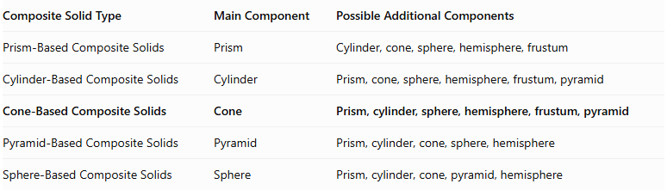
Composite Solid Type | Main Component | Possible Additional Components
Prism-Based Composite Solids | Prism | Cylinder, cone, sphere, hemisphere, frustum
Cylinder-Based Composite Solids | Cylinder | Prism, cone, sphere, hemisphere, frustum, pyramid
Cone-Based Composite Solids | Cone | Prism, cylinder, sphere, hemisphere, frustum, pyramid
Pyramid-Based Composite Solids | Pyramid | Prism, cylinder, cone, sphere, hemisphere
Sphere-Based Composite Solids | Sphere | Prism, cylinder, cone, pyramid, hemisphere

Applications
# Source: AI Source: Provided by: [Data Path: Persons Table -> ID Column: 1, Name_En Column: Motasem Essam] -> From: [ChatGPT] on [7/25/2026]
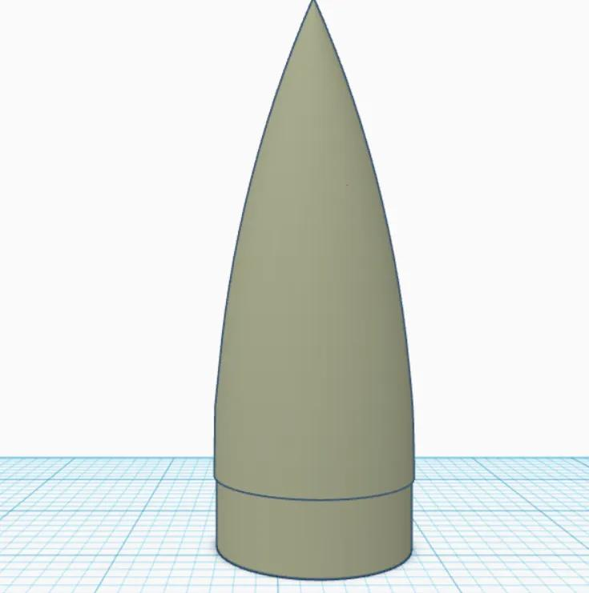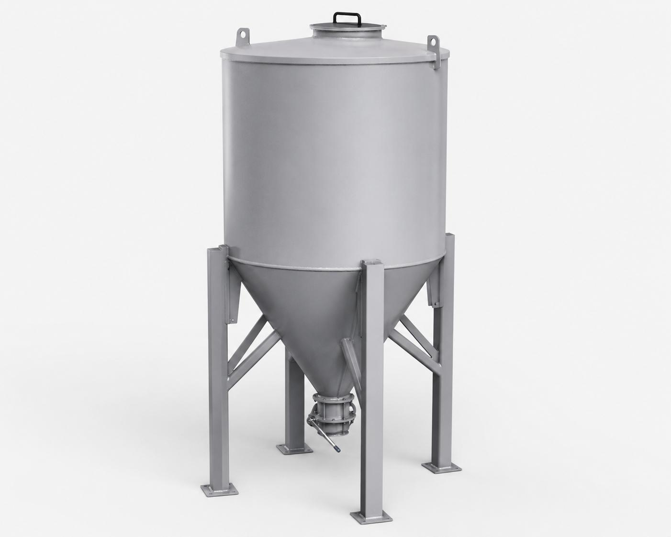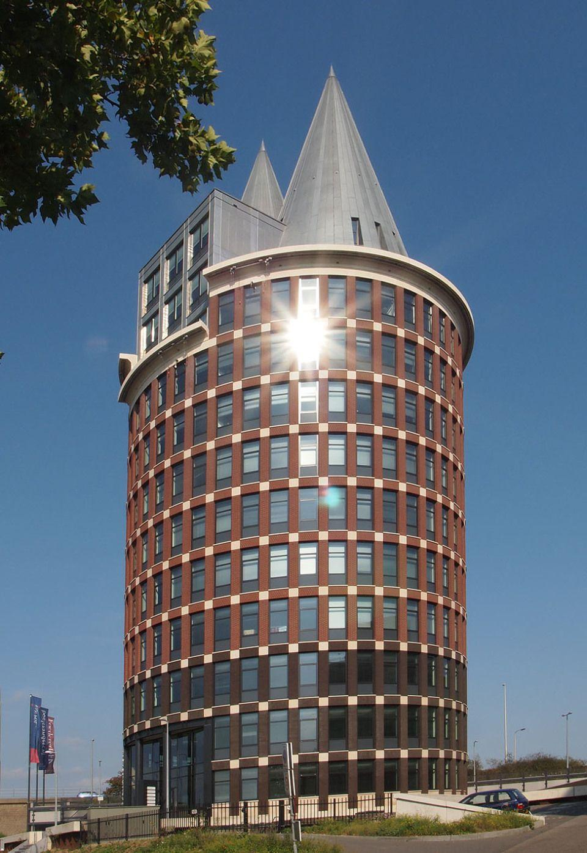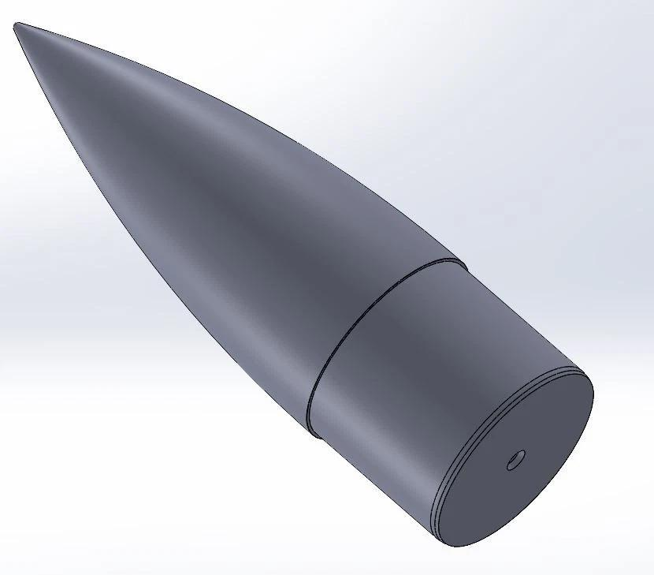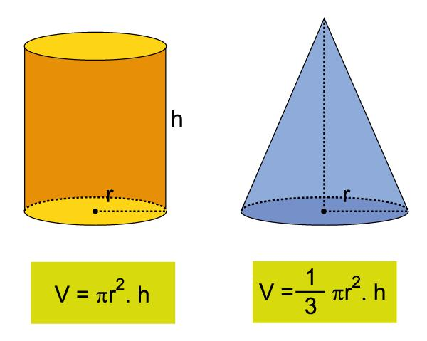
Cone-based composite solids are commonly found in:
- Aerospace Engineering: Rocket bodies, nose cones, and aerodynamic structures.
- Architecture: Conical roofs, towers, decorative structures, and building components.
- Mechanical Engineering: Funnels, nozzles, machine components, and specialized equipment.
- Manufacturing: Hoppers, containers, molds, and industrial machinery.
- Construction: Conical roofs, structural supports, and specialized building elements.
- Automotive Engineering: Conical components, nozzles, and mechanical assemblies.
- Product Design: Traffic cones, funnels, lampshades, and household products.
- Industrial Design: Storage equipment, dispensing systems, and material-handling devices.
- Computer-Aided Design (CAD): Modeling complex objects using cones and other geometric components.

Key Points
# Source: AI Source: Provided by: [Data Path: Persons Table -> ID Column: 1, Name_En Column: Motasem Essam] -> From: [ChatGPT] on [7/25/2026]
- Cone-based composite solids contain at least one conical component.
- They can combine cones with prisms, cylinders, spheres, hemispheres, frustums, and pyramids.
- Their external surfaces may include flat and curved regions.
- Their volume is calculated by combining component volumes while accounting for overlaps.
- Their external surface area includes only exposed surfaces.
- Joining surfaces that become internal must not be counted.
- Cone arrangements can include base-to-base, coaxial, side-attached, and multiple-component configurations.
- Apex-to-apex contact is a point connection rather than a face-to-face connection.

Conclusion
# Source: AI Source: Provided by: [Data Path: Persons Table -> ID Column: 1, Name_En Column: Motasem Essam] -> From: [ChatGPT] on [7/25/2026]
Cone-Based Composite Solids are an important category of composite geometric solids formed by combining cones with other flat-faced or curved-surface solids. They create a wide variety of three-dimensional structures with different arrangements, dimensions, and surface combinations.
Understanding their components, classifications, volume formulas, and external surface-area calculations provides a foundation for studying complex geometric objects and their applications in engineering, architecture, manufacturing, and design.

